
Sukkur IBA University
Department of Computer Science
ESE-201: Digital Logic Design Lab

Lab # 06: Decoder
Instructor: Muhammad Ismail Qureshi
Submission Profile
Name: Submission date (dd/mm/yy):
CMS ID: Marks obtained:
Comments: Receiving authority name and signature:

________________________________________________________________________________
Instructor Signature

Note: Submit this lab hand-out on LMS/e-learning before the next lab with attached solved activities and exercises.
Lab Learning Objectives:

Upon successful completion of this experiment, the student will be able:
- To implement and verify Decoder operations using 74LS42 IC & NI ELVIS Kit

Lab Hardware and Software Required:
- 74LS42 IC (BCD-to-Decimal Decoder)
- NI ELVIS Kit
- Breadboard
- Connecting Wires

Background Theory:

Decoder:
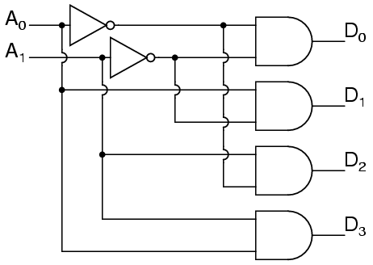
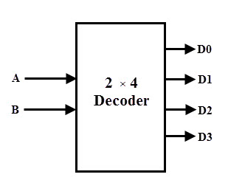
Decoder is a logic circuit that accepts a set of inputs that represents a binary number and activates only the output that corresponds to that input number. In other words, a decoder circuit looks at its inputs, determines which number is present there, and activates one output that corresponds to that number; all other outputs remain inactive. Before the design of decoder, we must decide that whether we want an active high level output or an active low level output to indicate the value selected. For an active-high indication the required output is high and all other all other outputs are low; while in case of active-low, the required output is low and all other outputs are high. Fig 6.1 (a & b) shows the logic symbol and logic diagram for 2x 4 decoder. It uses all AND gates, so the outputs are active high. For a given input code, the only output that is active (high), is one corresponding to decimal equivalent of the binary input code.
Fig 6.1: (a) Logic Symbol of 2 x 4 Decoder (b) Logic Diagram of 2 x 4 Decoder
74LS42 Decoder IC:
The TTL 74LS42 accepts four lines of input data and it has ten active-low outputs. The inputs must be supplied by a coder type BCD, which causes the activation of the output line corresponding to the applied number. Each output goes low only when its corresponding BCD input is applied, while all other inputs remain high. Fig 6.2 shows the pin-out of 74LS42 IC.
Fig 6.2: 74LS42 Decoder IC pin configuration
Lab Examples:
Implementation of 2 x 4 Decoder:
- Carry out the pin configuration of 74LS42 IC
- Take 74LS42 IC and insert it in the breadboard present on the NI ELVIS-II kit
- Apply power supply to it
- Connect inputs A and B to two switches SW0 and SW1
- Connect the output Q0 to Q3 to the LEDs
- Set all the combinations of observation table with the help of switches and fill the observation table.
Table 6.1: Observation table of Decoder
Input |  | Output (Y)
B | A | Q0 | Q1 | Q2 | Q3
 |  | LED (on / off) | LED (on / off) | LED (on / off) | LED (on / off)
0 | 0
0 | 1
1 | 0
1 | 1
Note: The output of the decoder (BCD to Decimal) is in negative logic, so a line results as active when the corresponding LED keeps off.

Lab Activities:
Implementation of BCD-to-Decimal Decoder using 74LS42:
- Connect the inputs A, B, C and D to the switches
- Connect outputs 0, 1, 2, 3, 4, 5, 6, 7, 8, and 9 to the LEDs
- Compose all binary numbers from 0 to 9 and analyse the state of LEDs
Table 6.2: Observation table of BCD-to-Decimal Decoder
Input |  |  |  | Output (Y)
D | C | B | A | 0 | 1 | 2 | 3 | 4 | 5 | 6 | 7 | 8 | 9

Lab Exercises:
Make BCD to decimal decoder using Multisim. Input should be last digit of your CMS ID.

